**Name: KishorKumar Polepalle**

**ID:** [**2022mt13128@wilp.bits-pilani.ac.in**](mailto:2022mt13128@wilp.bits-pilani.ac.in)

**App Name: flutterwithback4app TODO List**

**Git URL:** [**https://github.com/kishor2406/FlutterWithBack4App/tree/main**](https://github.com/kishor2406/FlutterWithBack4App/tree/main)

**Flutter CRUD Database Operations on Parse**

**1 - Created Todo App Template**

**2 - Connected Template to Back4app Project**

**3 - Coded for Create Object**

**4 - Coded for Read Object**

**5 - Coded for Update Object**

**6 - Coded for Delete Object**

**Prerequisites**

* **Installed Flutter version 2.2.x**
* **VS Code installed (with Plugins Dart and Flutter)**
* **An app created on Back4App:**

**Task Management**

**Pubspec.yaml is updated with correct version**

**dependencies:**

**parse_server_sdk_flutter: ^3.1.0**

**flutter:**

**sdk: flutter**

**An Flutter app connected to Back4app.**

**Note: Followed the Install Parse SDK on Flutter project to create an Flutter Project connected to Back4App.**

**A device (or virtual device) running Android or iOS.**

**1 - Create Todo App Template**

**Opened the Flutter project from the previous guide Flutter plugin for Parse Server.**

**Go >> open main.dart file in VS code, updated the application id and client key values:**

**2 - Connected Template to Back4app Project**

**Find outApplication Id and Client Key credentials navigating to your app Dashboard at Back4App Website.**

**Update your code in main.dart with the values of your project’s ApplicationId and ClientKey in Back4app.**

**keyApplicationId = App Id**

**keyClientKey = Client Key**

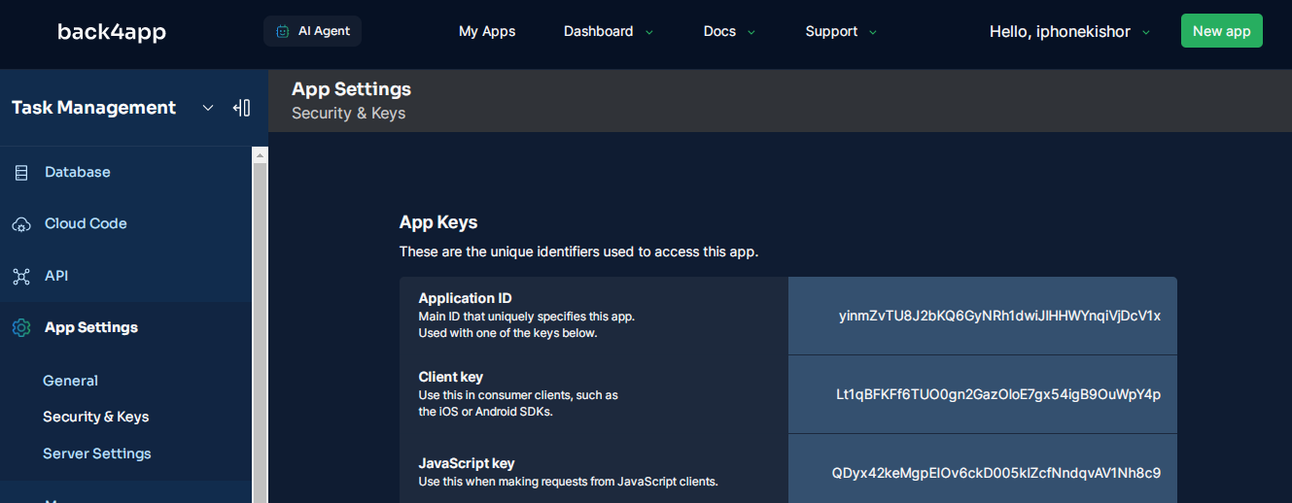

**Run the project**

**3 - Code for Create Object**

**The create function will create a new Task with the title and done status equal to false.**

**Search function saveTodo in file main.dart.**

**Replace code inside saveTodo with:**

**1 final todo = ParseObject('Todo')..set('title', title)..set('done', false);**

**2 await todo.save();**

**To build this function, follow these steps:**

**Make a new instance of the Parse Todo class with the command ParseObject('Todo').**

**Use the set function to set the paramenters for this object.**

**Call the save function, which will effectively register the task to your database in the Parse Dashboard.**

**4 - Code for Read Object**

**The read function is responsible for querying the database and returning the list of objects.**

**Search function getTodo in file main.dart.**

**5 - Code for Update Object**

**The update function is responsible for updating a task as completed or not.**

**Search function updateTodo in file main.dart.**

**The delete function is responsible for removing a task from database.**

**It is an irreversible action, which means that you should be careful while using it.**

**Search function deleteTodo in file main.dart.**

**Working as expected the create, read, update and delete todo list**